Name: Cyrille Leigh Evan M. Isayas BSIT-301

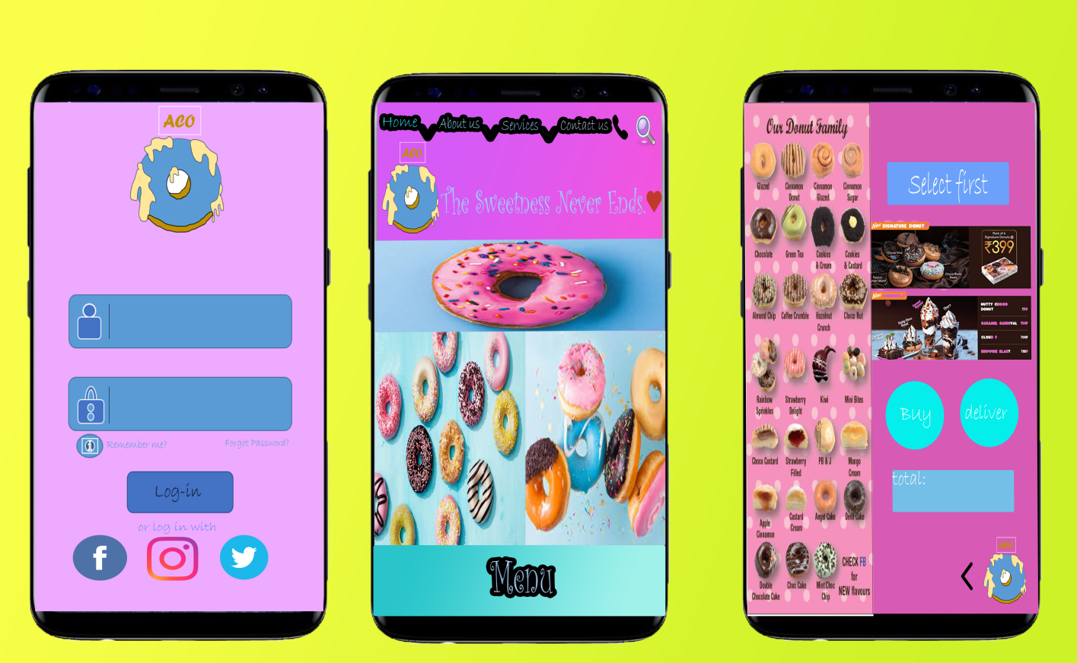I'd rather Choosed Mobile application because My Target people are working on industries like the common works of Pilipino's  people Call center. As you can see in these three photos, the left one has log in form as sign up approval it comes to understanding the task it define Analyzing the user's capability to navigate at a certain module of a program also it has the social media icon to making the user comfortable by allowing as easy log in(prevent errors and reversal action) And in the Middle it refers to the home page of my mobile application as you can notice it has a home, about us, services,Contact also a menu icon. you can click them form more information, And last Remind the user in the third picture of my mobile app, it has menu for donut and dessert which is you can click " select " to buy, and it can be deliver to you if you want ,also you can check your total of amount, confirming the safe receipt of a credit in online payment, as you notice it had lesser quantity item to because that is required for a human's short term memory to maintain good user awareness of the on going task.